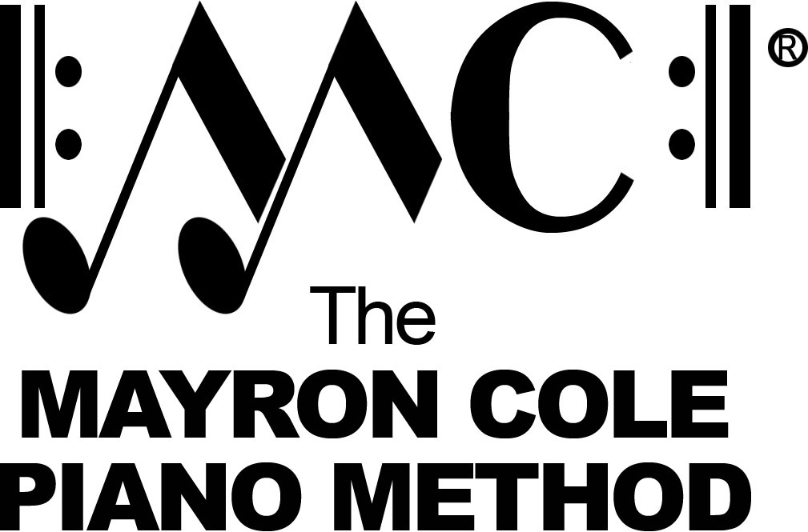

Older Beginner B
List of Contents

A Dark Night by Mayron Cole
A Cowboy’s Song by Mayron Cole
The Coffee Pot by Mayron Cole
London Bridge arranged by Mayron Cole
The Shadow Birds by Mayron Cole
March of the Penguins by Mayron Cole
Lucky Duck by Mayron Cole
Colleen’s Waltz by Mayron Cole
The Eyes of F by Mayron Cole
Going West by Mayron Cole
Old MacDonald arranged by Mayron Cole
The Viking by Mayron Cole
The Wandering Gypsy by Mayron Cole
County Fair by Mayron Cole
Lazy Dog Blues by Mayron Cole
Little Liza Jane arranged by Mayron Cole
Bingo arranged by Mayron Cole
Quiet Music by Mayron Cole
Brahm’s Lullaby arranged by Mayron Cole
Autumn Sounds by Mayron Cole
Hot Potato Polka by Mayron Cole
Boogie Bear by Mayron Cole
“Oh! Mindy Lou!” by Mayron Cole
Yankee Doodle arranged by Mayron Cole
Celebration Day by Mayron Cole
Ring the News! by Mayron Cole
Start at the Beginning by Mayron Cole
Gab! Gab! Yakkity Yak! by Mayron Cole
Three-Note Tune by Mayron Cole
How Come I Gab and You Speak? by Mayron Cole
Gypsy Dance by Mayron Cole
A Scary Thought! by Mayron Cole
Time Ticks Away by Mayron Cole
Eating Lemons! by Mayron Cole
The Windmill by Mayron Cole
Running in Circles by Mayron Cole
Sour Pickle Waltz by Mayron Cole
Garbage Day Blues by Mayron Cole
Louisiana Night by Mayron Cole

