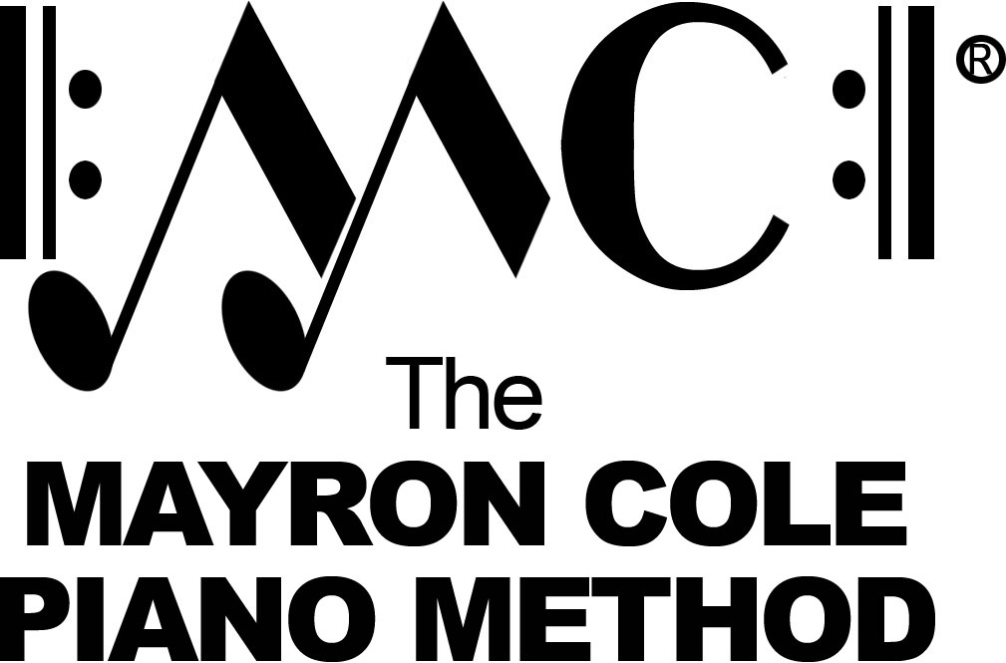

Older Beginner A
List of Contents

Tap! Tappey! Tap! Tap! by Mayron Cole
See the Leaves by Mayron Cole
Victory March by Mayron Cole
The Ticking Clock by Mayron Cole
School Bells by Mayron Cole
Green Toad Boogie by Mayron Cole
Yellow Daisies by Mayron Cole
Autumn Waltz by Mayron Cole
The Butterfly by Mayron Cole
September Morning by Mayron Cole
Kimmie’s Tune by Mayron Cole
Yukky Waltz by Mayron Cole
Indian Drums by Mayron Cole
The Broken Clock by Mayron Cole
Spring Fever by Mayron Cole
Four O’Clock in the Morning by Mayron Cole
Little Mice by Mayron Cole
Tiptoe by Mayron Cole
Running Around by Mayron Cole
Lazy Days by Mayron Cole
Swinging by Mayron Cole
Summer is Over by Mayron Cole
Skipping Rocks by Mayron Cole
The Squeaky Gate by Mayron Cole
Mountain Echo by Mayron Cole
A Sharp Piece! by Mayron Cole
Running in Circles by Mayron Cole
Fourteen Birdies by Mayron Cole
Indian Campfires by Mayron Cole
Little Church Bells by Mayron Cole
Ring Those Bells! by Mayron Cole
Autumn Bells by Mayron Cole
Blue Skies & Gray Skies by Mayron Cole
Country Morning by Mayron Cole
Back to B.C. by Mayron Cole
Skip to My Lou by Mayron Cole
Hot Summer Day by Mayron Cole
Night Music by Mayron Cole
Morning Music by Mayron Cole
Little Snowflakes by Mayron Cole
Return of Robin by Mayron Cole
Spring Breeze by Mayron Cole
Distant Drums by Mayron Cole
Ellisa! by Mayron Cole
The Last Leaf by Mayron Cole
Ev’rybody, Clap Your Hands! by Mayron Cole

