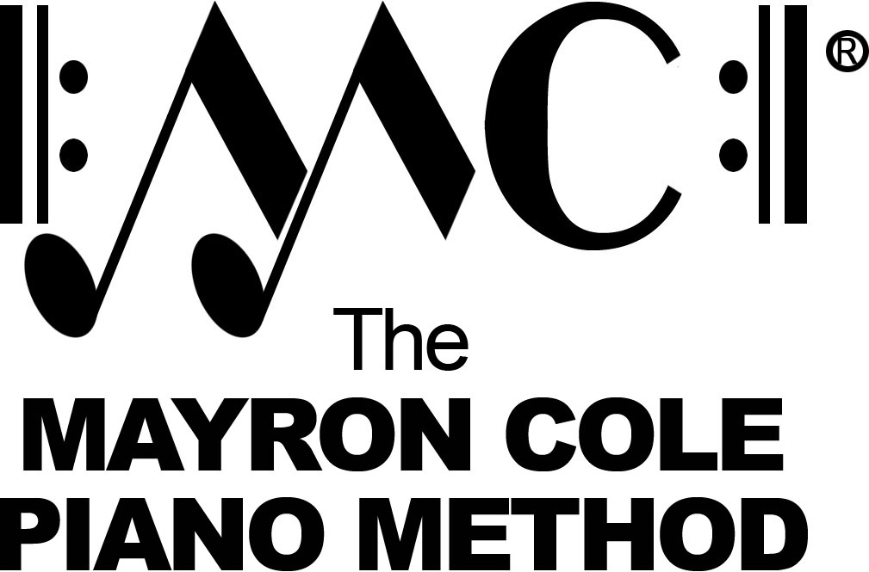

Menehune Music
List of Contents

Hello, Class! How Are You? by Mayron Cole
I’ve Got A Dog! by Mayron Cole
Hear The Wind Blow by Mayron Cole
I Like Porridge Hot! by Mayron Cole
Hear The Old Freight Train by Mayron Cole
When I Go To Sleep by Mayron Cole
Somebody’s Knocking! by Mayron Cole
Marching Along! by Mayron Cole
The Morning Bird by Mayron Cole
White Clouds by Mayron Cole
I Can Run Fast by Mayron Cole
Sleepy Time by Mayron Cole
Winter’s Here! by Mayron Cole
Dark Forest by Mayron Cole
I Like Porridge Hot! (F) by Mayron Cole
I’ve Got a Dog! (F) by Mayron Cole
Long Ago by Mayron Cole
Busy Bee by Mayron Cole
The Indian Drummer by Mayron Cole
Hello, Class! How Are You? (B) by Mayron Cole
Walking To School by Mayron Cole
Hear the Wind Blow (G/A) by Mayron Cole
When I Go To Sleep (G/A) by Mayron Cole
Mountain Stream by Mayron Cole
The Queen’s Coronation by Mayron Cole
Hear The Old Freight Train by Mayron Cole
Flying by Mayron Cole
Country Fiddler by Mayron Cole
The Cowboy’s Song by Mayron Cole
The Banjo Player by Mayron Cole
Good-Bye, Summer! by Mayron Cole
Sea Gulls by Mayron Cole

