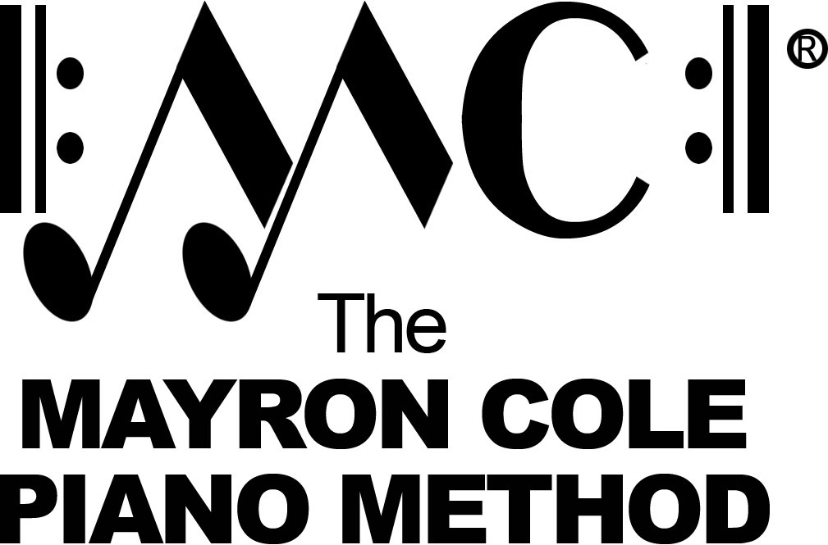

Level 7A
List of Contents

William’s Waltz by Mayron Cole

Sing Noel! Sing! by Mayron Cole

Jazz Bird by Mayron Cole
arranged by Colleen Cole

Graduation Memories by Mayron Cole

Flight of the Snow Geese by Mayron Cole

It’s 5 to 6! by Mayron Cole
arranged by Colleen Cole

Ellisa’s Journey by Mayron Cole

Waltz in D-Flat by Frederic Chopin
“The Minute Waltz”

