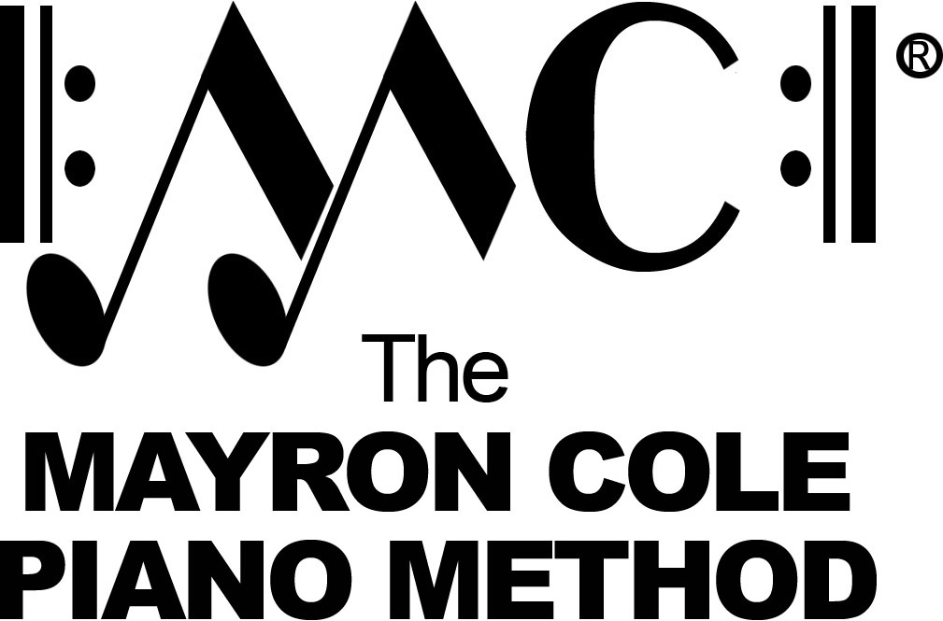

Level 6B
List of Contents

Minuet in G by J. S. Bach
Sarabande by G.F. Handel
English Gigue by G.P. Telemann
Waltz of Gratz by F. Schubert
The Treehouse by Mayron Cole
Pastorale by C.P.E. Bach
Song of the Frog by Mayron Cole
and the Nightbird
Lightnin’ Bugs by Mayron Cole
October Morn by Mayron Cole
Camel Caravan by Mayron Cole
Grand Finale Circus March by Mayron Cole
Allegretto Scherzando by C.G. Neefe
(3 piano parts)
Wash Rag by Mayron Cole

