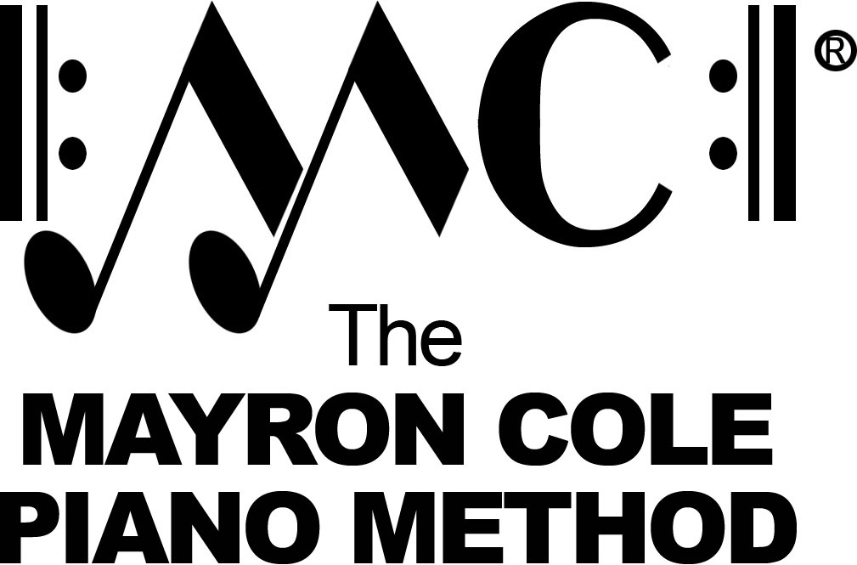

Level 5B
List of Contents

Spinning Song by Albert Ellmenreich
Country Waltz by Joseph Haydn
March by Dmitri Shostakovich
The Clown by Dmitri Kabalevsky
Summer Breeze by Mayron Cole
Circus Train by Mayron Cole
Chinese Acrobats by Mayron Cole
Here Come the Clowns! by Mayron Cole
Soldier’s March by Robert Schumann
Gypsy Dance by Joseph Haydn
Shadow Waltz by Mayron Cole
Ballade by Johann Burgmuller
Sonatina, Op. 36, No. 1, Vivace by Muzio Clementi
Musette by J.S. Bach

