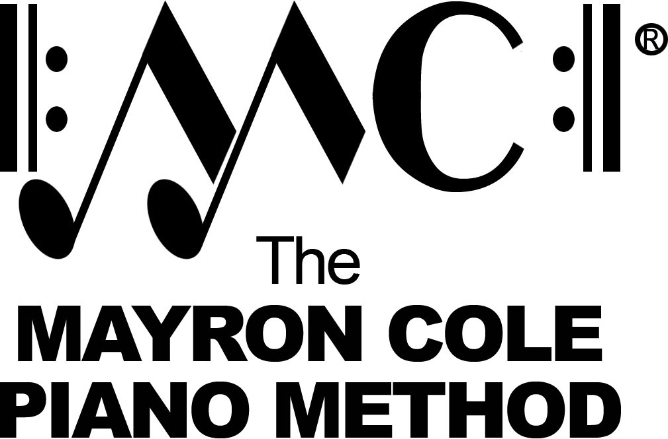

Level 4B
List of Contents

Russian Folk Song by Ludwig Beethoven
Spider Web by Mayron Cole
Landler by Wolfgang Mozart
The Fruit Vendor by Mayron Cole
Bourdon by Francois Couperin
Bouree by Leopold Mozart
Melody by Friedrich Baumfelder
The Long Road by Mayron Cole
Minuet by Leopold Mozart
Alexander’s March by Ludwig Beethoven
Organ Grinder by Vladimir Rebikoff
Minuet in D Minor by J.S. Bach
Musette by Felix Le Couppey
Cabbage! by Mayron Cole
Turkey from Albuquerque by Mayron Cole

