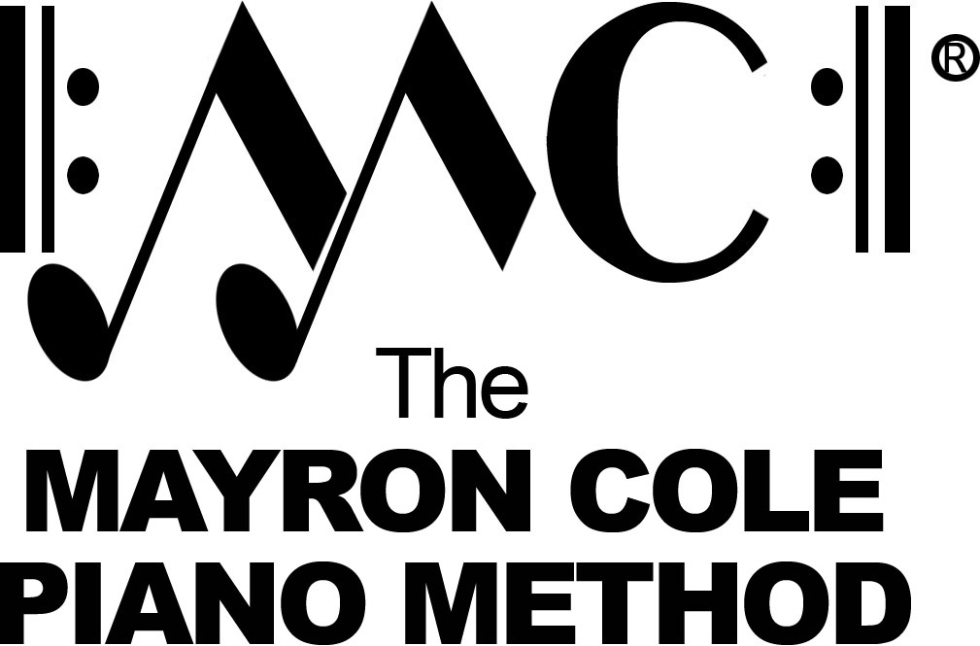

Level 2A
List of Contents

Start at the Beginning by Mayron Cole
Gab! Gab! Yakkity Yak! by Mayron Cole
Three-Note Tune by Mayron Cole
How Come I Gab & you Speak? by Mayron Cole
Gypsy Dance by Mayron Cole
A Scary Thought! by Mayron Cole
Time Ticks Away by Mayron Cole
Evening Song by Mayron Cole
The Windmill by Mayron Cole
Running in Circles by Mayron Cole
Sour Pickle Waltz by Mayron Cole
Garbage Day Blues by Mayron Cole
A Lonely Day by Mayron Cole
Eating Lemons! by Mayron Cole
Louisiana Night by Mayron Cole
Changing of the Guard by Mayron Cole
Winter Waltz by Mayron Cole
King of the North by Mayron Cole
The Ice Skater by Mayron Cole
October Evening by Mayron Cole
The Giant Goes Jogging by Mayron Cole
Popcorn by Mayron Cole
Betsy Biddle Plays the Bass Fiddle by Mayron Cole
By the Bayou by Mayron Cole
The Bicycle Rider by Mayron Cole
Ellisa and Colleen by Mayron Cole
Injun Joe by Mayron Cole
Saturday Song by Mayron Cole

