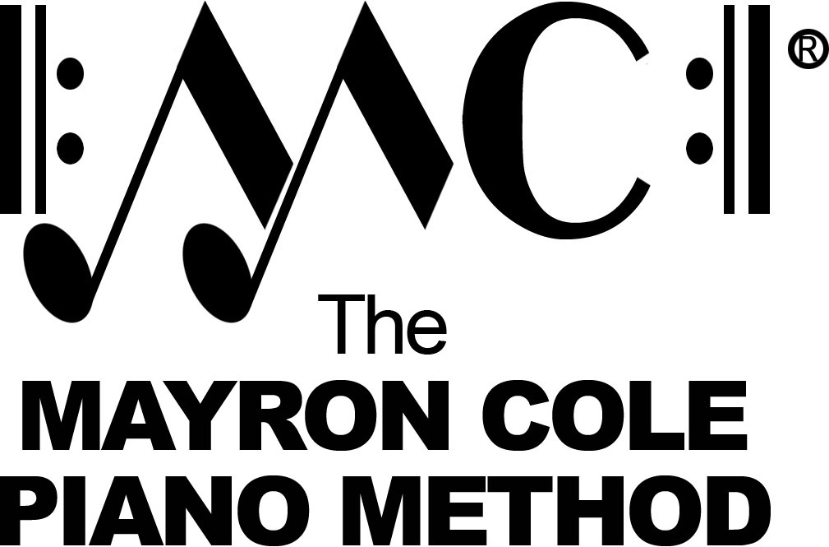

Level 1B
List of Contents

A Dark Night by Mayron Cole
A Cowboy’s Song by Mayron Cole
The Coffee Pot by Mayron Cole
London Bridge arranged by Mayron Cole
The Shadow Birds by Mayron Cole
March of the Penguins by Mayron Cole
Lucky Duck by Mayron Cole
Colleen’s Waltz by Mayron Cole
Little Robin Redbreast by Mayron Cole
The Mulberry Bush arranged by Mayron Cole
Seesaw, Margery Daw arranged by Mayron Cole
The Eyes of F by Mayron Cole
Going West! by Mayron Cole
Old MacDonald arranged by Mayron Cole
The Viking by Mayron Cole
The Wandering Gypsy by Mayron Cole

