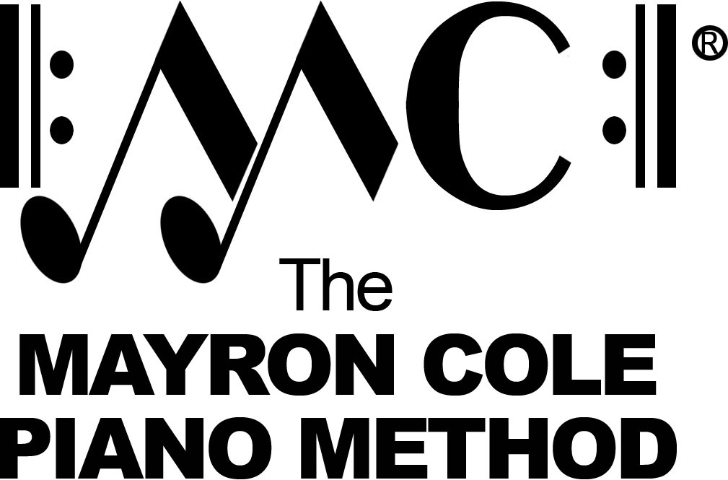

EZ Keys 3
List of Contents

Country Days by Mayron Cole
Sunrise on the Farm part #2 by Mayron Cole
Two Little Goats part #2 by Mayron Cole
On This Farm part #2 by Mayron Cole
Star Bright in the Sky part #3 by Mayron Cole
Day’s End by Mayron Cole
White Clouds part #2 by Mayron Cole
Plowing the Corn Rows part #1 by Mayron Cole
Under the Oak Tree by Mayron Cole
Plowing the Corn Rows part #2 by Mayron Cole
Sitting in the Shade by Mayron Cole
Old Owl in the Tree part #2 by Mayron Cole
Three Little Goats part #3 by Mayron Cole
Sun’s Set part #2 by Mayron Cole
Every Morning part #2 by Mayron Cole
Bullfrog Jamboree part #2 by Mayron Cole
Hear the Beat by Mayron Cole
Hear the Wind Blow! by Mayron Cole
Dandelions Blowing by Mayron Cole

Compositions with two or three parts in
EZ KEYS BOOK TWO and EZ KEYS BOOK THREE
may be played together as an ensemble.

