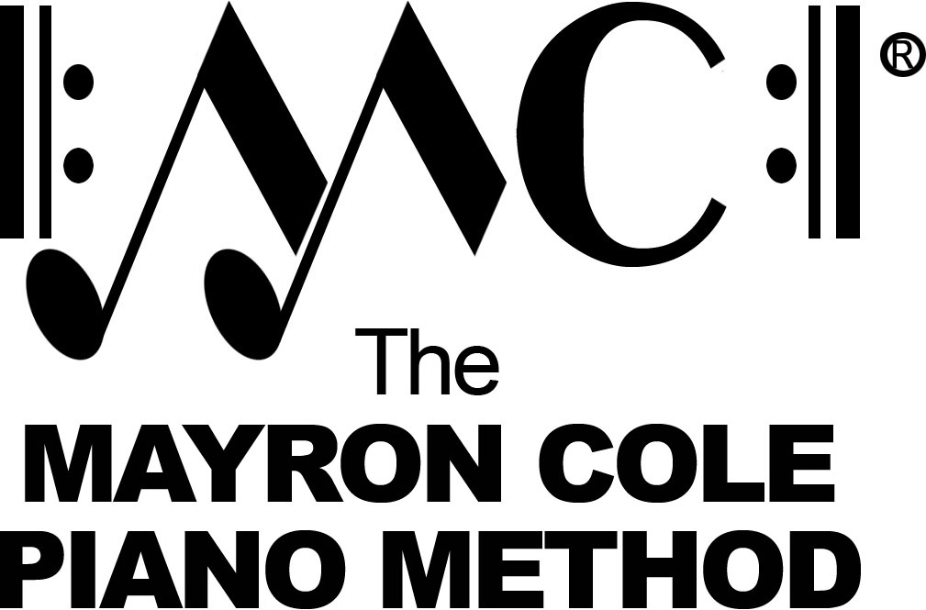

EZ Keys 2
List of Contents

Country Days by Mayron Cole
Sun’s Set part #1 by Mayron Cole
Star Bright in the Sky part #1 by Mayron Cole
Golden Pumpkins by Mayron Cole
Old Owl in the Tree part #1 by Mayron Cole
On This Farm by Mayron Cole
One Little Goat part #1 by Mayron Cole
The Old Scarecrow by Mayron Cole
Fall Days by Mayron Cole
Sunrise on the Farm part #1 by Mayron Cole
Geese Flying South by Mayron Cole
Tap! Tappey! by Mayron Cole
I’ve Got a Goat part #1 by Mayron Cole
Every Morning by Mayron Cole
I Love to Hoe Potatoes! by Mayron Cole
Bullfrog Jamboree part #1 by Mayron Cole
Star Bright in the Sky part #2 by Mayron Cole
White Clouds part #1 by Mayron Cole

Compositions with two or three parts in
EZ KEYS BOOK TWO and EZ KEYS BOOK THREE
may be played together as an ensemble.

