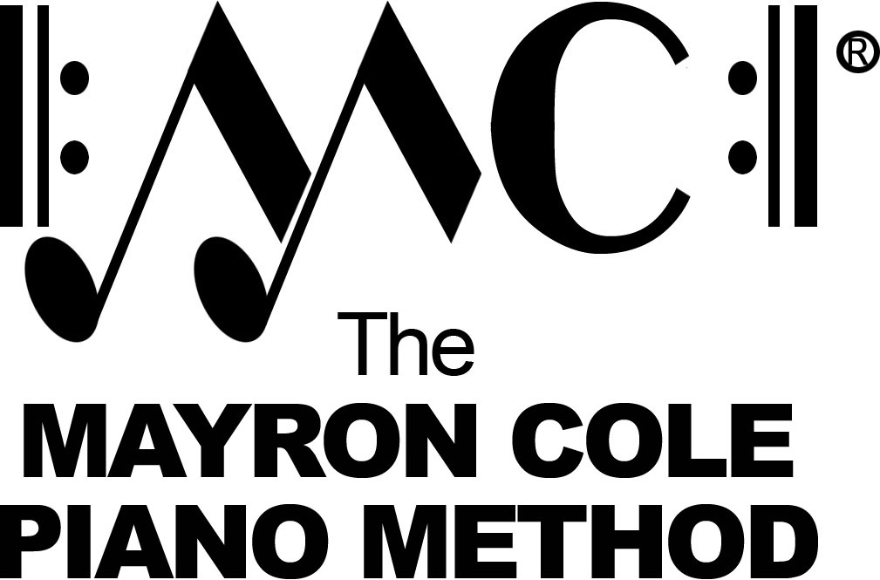

EZ Keys 1
List of Contents

Every Morning by Mayron Cole
I Love to Hoe Potatoes by Mayron Cole
Riding Ponies by Mayron Cole
Hello, Hen! by Mayron Cole
Hear the Beat! by Mayron Cole
Tap! Tappey! by Mayron Cole
I’ve Got a Pig by Mayron Cole
Hear the Wind Blow by Mayron Cole
White Clouds by Mayron Cole
Plowing the Corn Rows by Mayron Cole
Slow Pokes by Mayron Cole
Sunrise on the Farm by Mayron Cole
Day’s End by Mayron Cole
On This Farm by Mayron Cole
There Goes Number 9 by Mayron Cole
Star Bright in the Sky by Mayron Cole
Fall Days by Mayron Cole
Golden Pumpkins by Mayron Cole
Geese Flying South by Mayron Cole
Country Days by Mayron Cole

EZ Keys 2
List of Contents

Country Days by Mayron Cole
Sun’s Set part #1 by Mayron Cole
Star Bright in the Sky part #1 by Mayron Cole
Golden Pumpkins by Mayron Cole
Old Owl in the Tree part #1 by Mayron Cole
On This Farm by Mayron Cole
One Little Goat part #1 by Mayron Cole
The Old Scarecrow by Mayron Cole
Fall Days by Mayron Cole
Sunrise on the Farm part #1 by Mayron Cole
Geese Flying South by Mayron Cole
Tap! Tappey! by Mayron Cole
I’ve Got a Goat part #1 by Mayron Cole
Every Morning by Mayron Cole
I Love to Hoe Potatoes! by Mayron Cole
Bullfrog Jamboree part #1 by Mayron Cole
Star Bright in the Sky part #2 by Mayron Cole
White Clouds part #1 by Mayron Cole

EZ Keys 3
List of Contents

Country Days by Mayron Cole
Sunrise on the Farm part #2 by Mayron Cole
Two Little Goats part #2 by Mayron Cole
On This Farm part #2 by Mayron Cole
Star Bright in the Sky part #3 by Mayron Cole
Day’s End by Mayron Cole
White Clouds part #2 by Mayron Cole
Plowing the Corn Rows part #1 by Mayron Cole
Under the Oak Tree by Mayron Cole
Plowing the Corn Rows part #2 by Mayron Cole
Sitting in the Shade by Mayron Cole
Old Owl in the Tree part #2 by Mayron Cole
Three Little Goats part #3 by Mayron Cole
Sun’s Set part #2 by Mayron Cole
Every Morning part #2 by Mayron Cole
Bullfrog Jamboree part #2 by Mayron Cole
Hear the Beat by Mayron Cole
Hear the Wind Blow! by Mayron Cole
Dandelions Blowing by Mayron Cole

Compositions with two or three parts in
EZ KEYS BOOK TWO and EZ KEYS BOOK THREE
may be played together as an ensemble.

